(Approx. 1676 words)

WATCH A ZOOM MEETING ON YOUR HDTV
The big screen may make details easier to see and is easier to share with family members
Part 2 of a 2-part articles series
By John Krout, Presenter & Newsletter Contributor
Potomac Area Technology and Computer Society
https://www.patacs.org
jkrout.apcug.presenter (at) gmail.com

INTRODUCTION

As noted in Part 1, there are many reasons why you may want to watch a Zoom teleconference on your flat-screen HDTV rather than on a tiny phone or tablet screen.
This Part 2 article explains how you can connect your tablet or smartphone to an HDTV so that you can see the Zoom teleconference on a big screen.

As explained in Part 1, in general, there are two methods for connecting a tablet or smartphone to an HDTV:

(1) connect the Zoom device to the TV using an HDMI cable, or

(2) connect the Zoom device to the TV or a network-connected media box, using your home Local Area Network (LAN).

These techniques are not limited to Zoom alone. Since the connection methods share the tablet or smartphone screen, the connection methods will work with any other app running on a tablet or phone. Games, email apps, weather apps, even split the device screen so you can see two apps side by side on the TV.

Using an HDMI cable, the first method is your only choice if your HDTV is not a modern smart TV and is not attached to any network-connected media box, such as a Roku or Chromecast. If you do not know if your TV qualifies as a smart TV, such HDTVs provide a Web browser inside the TV and often many other apps such as Amazon, YouTube, and so forth. And smart TVs almost always include an ethernet cable socket.

The second method, using your LAN, will work if yours is a smart TV connected to your home or, if yours is not a smart TV, a network-connected media box is attached to your TV.

ASPECT RATIO ISSUES

It is rare that a tablet or smartphone screen is exactly the same aspect ratio (long side to short side) as the standard 16:9 aspect ratio of an HDTV.

My Android tablet screen resolution, 4.1 megapixels, exceeds the HDTV standard 2.1 megapixels but is 16:10, therefore not as wide as HDTV. When I connected my tablet to my HDTV, I saw black bands on the left and right side of the tablet screen image on the HDTV, and the image looked a tad bit compressed horizontally.

My Android smartphone screen resolution is 4.3 megapixels but is 19:9, wider than the standard 16:9 aspect ratio of HDTV. As a result, I saw black bands above and below the smartphone image on the TV.

Both devices offer to adjust video output when connected to an HDTV, so the device screen image files or almost fills the HDTV screen.

USING THE CABLE METHOD
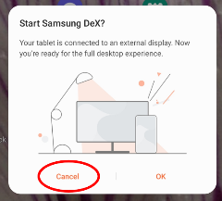
This method requires a Display Adapter accessory connected to your smartphone or tablet's data and charging port. For Android devices, that port is either micro-USB or USB-C. Some iPads also have a USB-C port. For most other iPhones and iPads, the port is Lightning. Older Android devices have micro-USB ports.

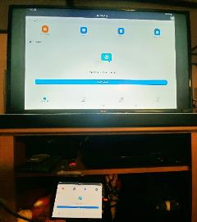
Fortunately, Display Adapters are not expensive. Since my phone and tablet have USB-C ports, I obtained a JSAUX brand Display Adapter with a USB-C plug for direct attachment to my phone or tablet. This item cost less than $15 and claims to be upward compatible with 4K video from the smartphone or tablet.
Illustration 1

When I tried connecting my tablet to my HDTV using the Display Adapter and an HDMI cable, initially, the tablet displayed the dialog box shown in illustration 1. DeX is a Samsung-specific technology that allows a tablet to be operated remotely by a personal computer, for instance. However, DeX is not useful when the tablet is connected to a TV since a TV has no mouse and no keyboard. So, when the tablet is connected to an HDTV, tap the CANCEL button, which is circled in the illustration.

Then I saw the tablet screen on my TV. So, I started the Zoom app on my tablet. Illustration 2 shows my 42" HDTV with my tablet below it, both displaying the Zoom app running on my tablet.
Illustration 2

USING THE LAN METHOD

In my case, I have a Roku Premiere+ box connected to my LG smart HDTV. Although both the TV and the Roku box are connected to my LAN, the tablet and smartphone scanned my LAN and found only the Roku box, so I chose to connect to that device.

My smartphone and tablet both have the Zoom Cloud meeting app installed. There is no need to configure the Zoom Cloud app to make the LAN method work because the LAN method displays the entire tablet or phone screen on the HDTV.

The following info is specifically for Android tablets and smartphones.

The key capability is already available on my Android 10 tablet and my Android 11 phone. Both are Samsung products. It is not available on my older Samsung tablet, which runs Android version 8.1.

However, on the Google support page for Chromecast, I found that any Android device running Android version 6 or later and any iOS device running iOS 12 or later can install the Google Home app to add Chromecast to the device.

HOW TO CAST PHONE/TABLET SCREEN TO HDTV

These instructions are specifically for Samsung brand phones or tablets. Each maker of Android devices has its own brand for the software that casts the device screen image to a TV, Roku, or Chromecast device. Samsung calls that cast software Smart View.

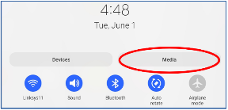
STEP 1. Make sure the HDTV is turned on.

If you plan to use Roku or Chromecast, then turn on that device, and set the TV's input to display that device.

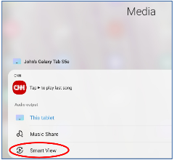
STEP 2. Since you cannot adjust the TV to Portrait orientation, you should use your phone or tablet in Landscape orientation, so the long edges of the screen are horizontal. That means you will see the highest resolution version of the tablet or phone screen on the TV screen.
Illustration 3

STEP 3. Pull down the top edge of the phone or tablet screen. Then, pull it all the way down.
Before this research, I had been consistently overlooking two large buttons, labeled Display and Media. You can see those buttons in illustration 3.

If you have used the top edge menu to lock the tablet or phone screen in Portrait mode, as I did initially, then you will have to unlock that feature so that the screen can rotate to Landscape orientation. The button for that purpose is the Auto Rotate button, immediately below the Media button.
Illustration 4

STEP 4. Tap the Media button, which is circled in the illustration.

The screen changes to the Media menu, shown in illustration 4.

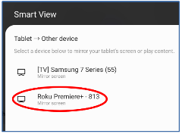
STEP 5. Tap the Smart View button circled in the illustration. The screen changes to show the Smart View menu and takes some time to identify all of the Smart View compatible devices on the home LAN. In my case, two devices were found, the Roku Premiere+ box and a Samsung TV. You can see that in illustration 5.

STEP 6. Tap the device to which you want to cast your tablet or phone.
Illustration 5
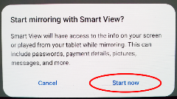
My LG TV was displaying the Roku box at the time. So I tapped Roku, which is circled in the illustration.

It may take several seconds for the connection to be established.

STEP 7. A popup dialog box appears on the tablet, as shown in illustration 6. Tap Start now to establish the cast, which is circled in the illustration.
Illustration 6

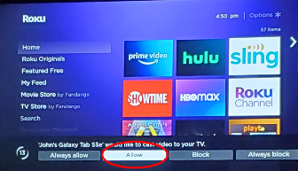
STEP 8. On the TV, Roku asked me for permission to display the cast screen from my tablet. You can see that in illustration 7. I used the Roku remote to select the Allow choice, which is circled in the illustration.

If you wish, you can instead choose Always Allow, the choice to the left of Allow, so you do not have to use the Roku remote every time you want to cast to the Roku box.
Illustration 7

At that point, the TV screen shows the same image as my tablet. I started the Zoom Cloud app on my tablet, and the TV screen showed the Zoom app too.

STEP 9. Once the smartphone or tablet learns the TV's aspect ratio, you will see another popup on the screen, asking if you want to adjust the video sent out by the smartphone or tablet to fill the TV screen. I recommend that you tap the Change button in the popup. This popup appears only during the first time you connect the portable device to the TV; after that, the portable device remembers your choice. After you do the Change once, the phone or tablet remembers that setting and, when you later connect to the TV, re-applies the setting.

At that point, I can start or join a Zoom teleconference on my tablet, and the TV shows it all. A key point is that the smartphone or tablet camera continues to act as the Zoom camera for you, but you can leave that camera disabled if you wish.

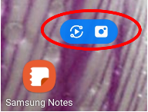
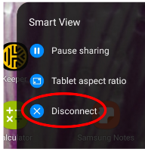
HOW TO END THE CONNECTION

On the tablet screen, a small icon is added. That icon is circled in illustration 8.

The icon contains two symbols. Each symbol does two different things during a cast. Tap the left side of the icon.
Illustration 8
Illustration 9
That tap brings in a menu, shown in illustration 9, including a Disconnect choice to end the cast. Tap that choice, and the cast is ended.

ABOUT THE AUTHOR: John Krout has been writing about creative uses of personal computers since the 1980s. He is a frequent contributor to PATACS Posts, the newsletter of the Potomac Area Technology and Computer Society, and occasionally provides presentations at PATACS meetings. He lives in Arlington, VA, with his son, many computers and digital cameras, and too many cats.

